|  |
| --- |
|  |
| Data Warehouse Architecture |

|  |  |  |  |  |  |
| --- | --- | --- | --- | --- | --- |
| REVISION HISTORY | | | | | |
| Ver. | Description of Change | Author | Date | Approved | |
| Name | Effective Date |
| 1.0 | Initial status | Arina Marchenko | 09-11-2017 |  |  |

Contents

Data Modeling Task 3

Analytical task 4

# Data Modeling Task

1. Creating table DATE_DIMENSION:

CREATE TABLE Date_Dimension (

Date_id DATE NOT NULL,

Day_per_week NUMBER(8),

Day_per_month NUMBER(8),

Day_per_year NUMBER(8),

Week_per_month NUMBER(8),

Week_per_year NUMBER(8),

Month_NUMBER NUMBER(8),

Month_name VARCHAR2(200),

Year NUMBER(8),

Day_Month VARCHAR2(200),

Year_Month VARCHAR2(200),

CONSTRAINT Date_id PRIMARY KEY (Date_id));

1. Insert into DATE_DIMENSION:

INSERT INTO Date_Dimension

SELECT SYSDATE+rownum-365*1018 as Date_id,

to_number(to_char(SYSDATE+rownum-365*1018-7*1, 'D'))as Day_per_week,

to_number(to_char(extract(day from SYSDATE+rownum-365*1018)))as Day_per_month,

to_number(to_char(SYSDATE+rownum-365*1018, 'DDD')) AS Day_per_year,

to_number(to_char(SYSDATE+rownum-365*1018, 'W')) AS Week_per_month,

to_number(to_char(SYSDATE+rownum-365*1018, 'IW')) AS Week_per_year,

to_number(to_char(extract(month from SYSDATE+rownum-365*1018))) as Month_number,

to_char(SYSDATE+rownum-365*1018, 'MONTH', 'NLS_DATE_LANGUAGE=English') AS Month_name,

to_number(to_char(extract(year from SYSDATE+rownum-365*1018))) as Year,

to_char(extract(day from SYSDATE+rownum-365*1018) || '-'|| to_char(extract(month from (SYSDATE+rownum-365*1018)))) as Day_Month,

to_char(extract(year from SYSDATE+rownum-365*1018) || '-'|| to_char(extract(month from (SYSDATE+rownum-365*1018)))) as Year_Month

FROM dual CONNECT BY rownum <=365*1018;

# Analytical task

* 3NF layer of Data Warehouse for my business.

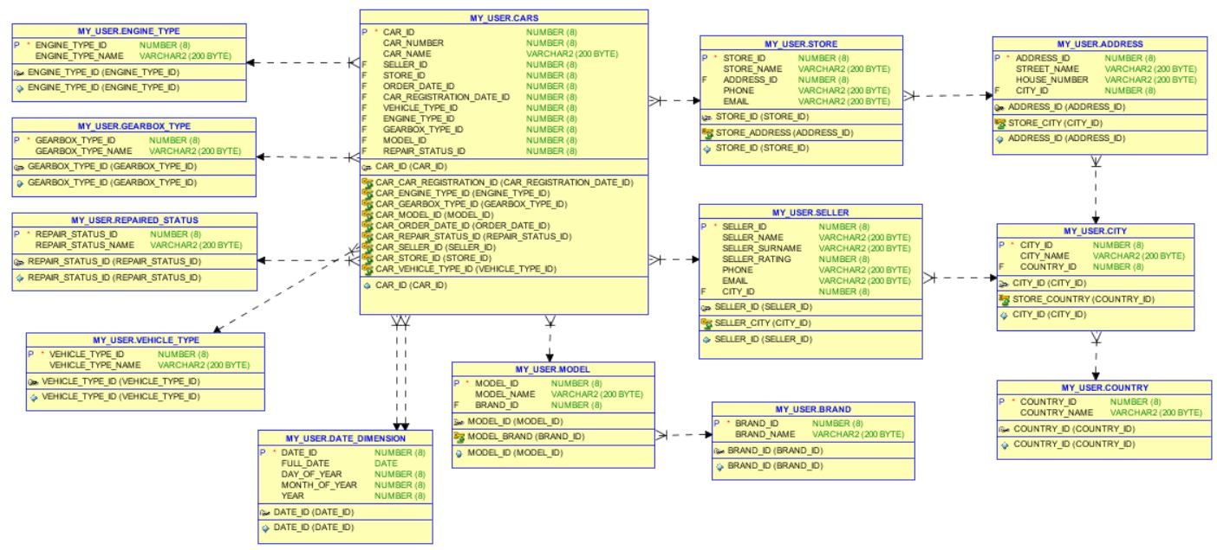

* Dimensional Model

